A: Look through the brochure. Analyze the structure and the
information presented in it. Do you thinkit gives all the necessary information?
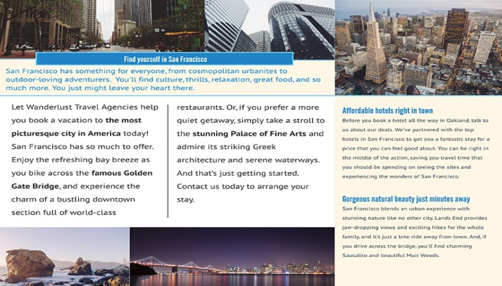
https://www.lucidpress.com/blog/how-to-make-a-travel-brochure-that-looks-stunning

B: Make a travel brochure.Think how you will structure the information.
C: Presenters: Present the brochure in class. Try to persuade the listeners to choose the vacation you suggest.
Listeners: Decide where you would like to spend your vacation. Why?
D (reflection): Analyse your presentation.
- Was it well-structured?
- Did you use sufficient information? Was it important?
- Were the arguments persuasive?
- What communication strategies did you use?
- What are the weak and strong points in it?
- Think on the skills which need special attention.
- How could you improve your presentation?

